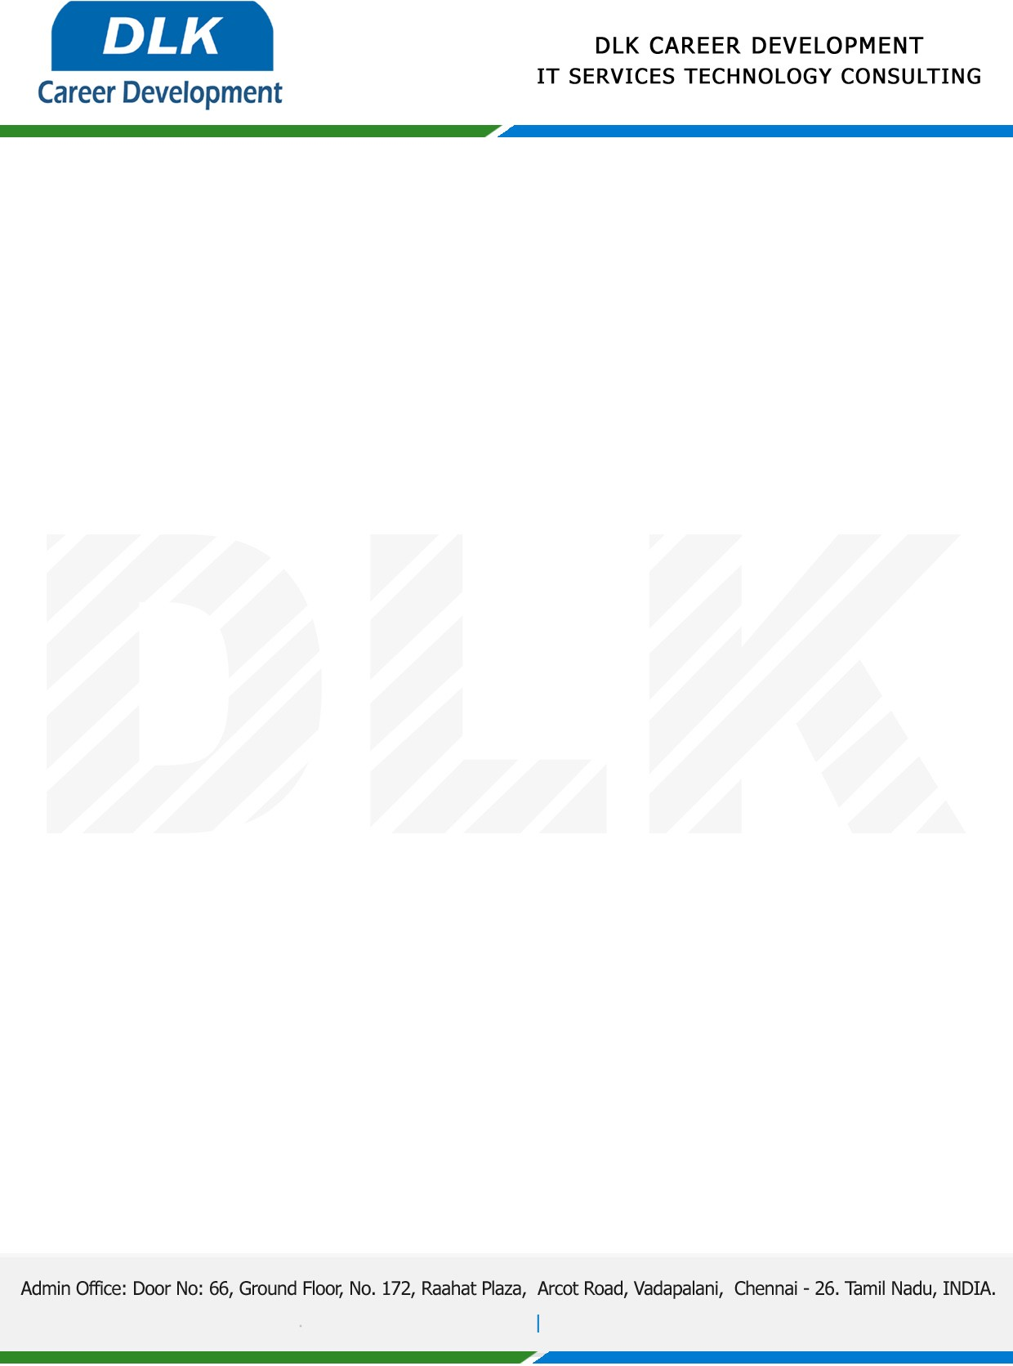

**Date: 03/May/ 2023**

**SUB: PROJECT COMPLETION CERTIFICATE**

This is to certify that **MR MOHAMED MUFARIS A (REG NO: 2113182080007)**

**MSC- Information Technology,** final year student at **The New College Chennai-14** has Successfully Completed his Project Work under the domain of “**PYTHON”** in our organization during the Period **(3rd January 2023 to 30th April 2023)**

**Topic**: Air quality prediction using machine learning and deep learning

We appreciate your interest in **DLK CAREER DEVELOPMENT**

**“Best Wishes for Your Future Endeavors “**

